**Ex. 17 Temperature Monitoring with Piezo Sensor**

**Aim**

To Simulate a temperature monitoring system with Piezo Sensor in Tinkercad

**Components Required**

1. Arduino
2. Breadboard
3. LED
4. Piezo Sensor
5. Temperature Sensor
6. Resistor

**Code**

int baselineTemp = 0;

int celsius = 0;

int fahrenheit = 0;

void setup()

{

pinMode(A0, INPUT);

Serial.begin(9600);

pinMode(2, OUTPUT);

pinMode(3, OUTPUT);

pinMode(4, OUTPUT);

pinMode(7, OUTPUT);

}

void loop()

{

baselineTemp = 40;

celsius = map(((analogRead(A0) - 20) * 3.04), 0, 1023, -40, 125);

fahrenheit = ((celsius * 9) / 5 + 32);

Serial.print(celsius);

Serial.print(" C, ");

Serial.print(fahrenheit);

Serial.println(" F");

if (celsius < baselineTemp) {

digitalWrite(2, LOW);

digitalWrite(3, LOW);

digitalWrite(4, LOW);

}

if (celsius >= baselineTemp && celsius < baselineTemp + 10) {

digitalWrite(2, HIGH);

digitalWrite(3, LOW);

digitalWrite(4, LOW);

}

if (celsius >= baselineTemp + 10 && celsius < baselineTemp + 20) {

digitalWrite(2, HIGH);

digitalWrite(3, HIGH);

digitalWrite(4, LOW);

}

if (celsius >= baselineTemp + 20 && celsius < baselineTemp + 30) {

digitalWrite(2, HIGH);

digitalWrite(3, HIGH);

digitalWrite(4, HIGH);

tone(7, 220, 100);

delay(100);

}

if (celsius >= baselineTemp + 30) {

digitalWrite(2, HIGH);

digitalWrite(3, HIGH);

digitalWrite(4, HIGH);

tone(7, 220, 100);

delay(100);

}

delay(1000);

}

**Circuit**

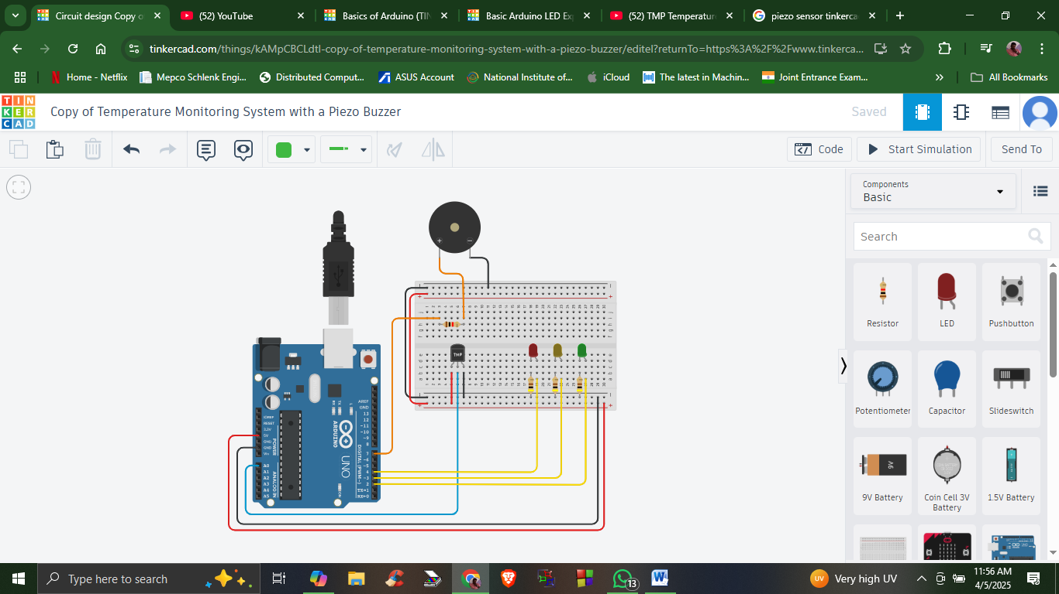

**Output**

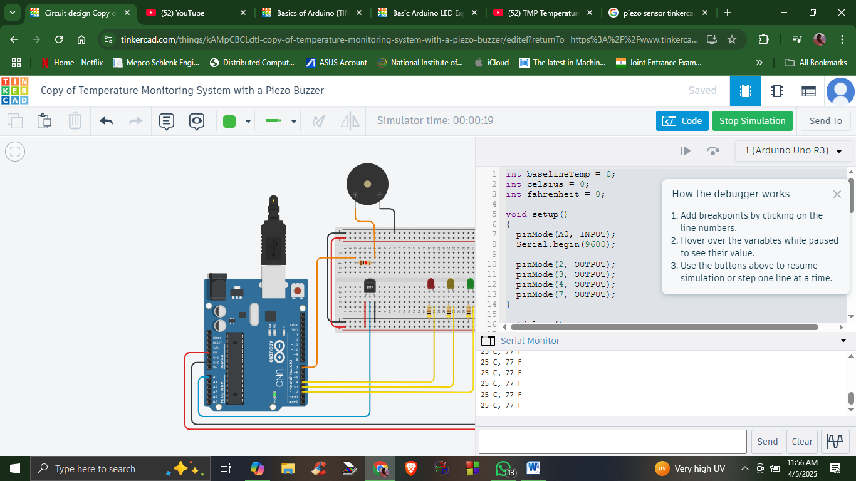

When maximum temperature is set the Piezo sensor vibrates.

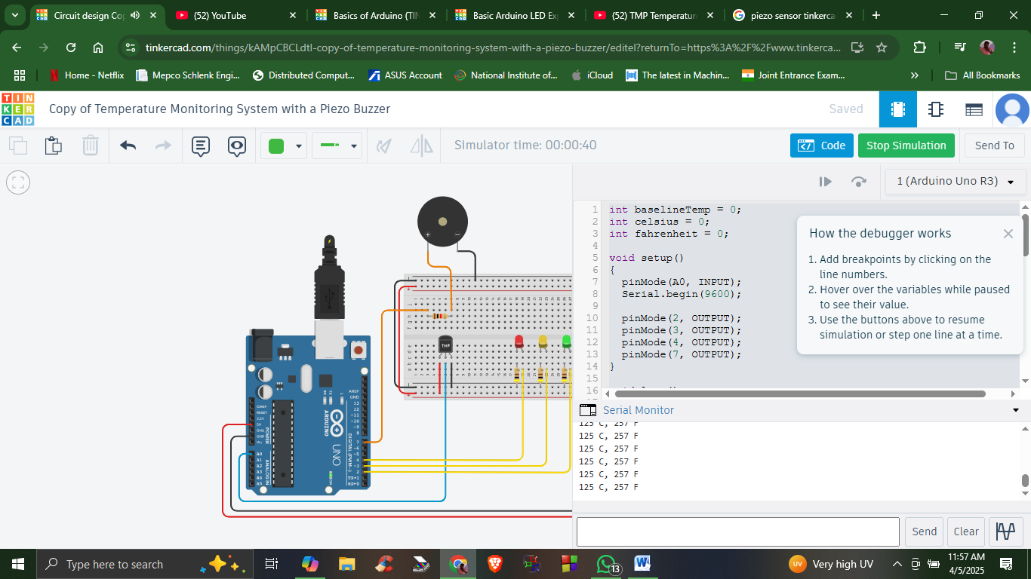

Notice by varying the temperature the LED glows one by one

All the three glows when the TMP is in maximum value